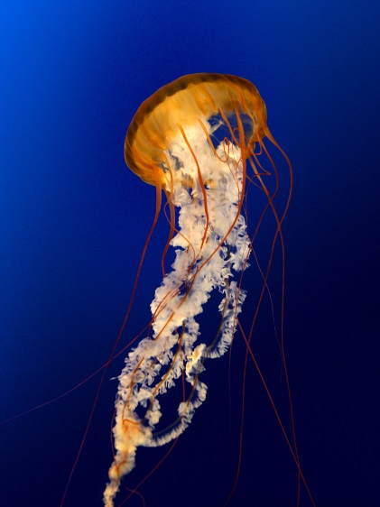
Jellyfish

Jellyfish have been around for millions of years, even before dinosaurs lived on the Earth. Pulsing along on our ocean currents, these jelly-like creatures can be found in waters both cold and warm, deep and shallow and along coastlines, too. Some jellyfish are clear, but others are vibrant colours of pink, yellow, blue and purple. They can be bioluminescent, too, which means they produce their own light!

